European Forum Alpbach 2019
International Evening

The Artificial Gap

Project Description

My idea is based upon “Giant Picnic” by the French Artist JR depicturing a huge picnic on the border of Mexico and the US. It shows an international picnic with hundreds of people sharing a meal across the fence. On both sides they eat exactly the same dish; the table they sit at displays the eyes of an American Dreamer. Hence, the art piece “Giant Picnic” reflects the irrelevance of borders if there is the will of the people to focus on the commonalities.

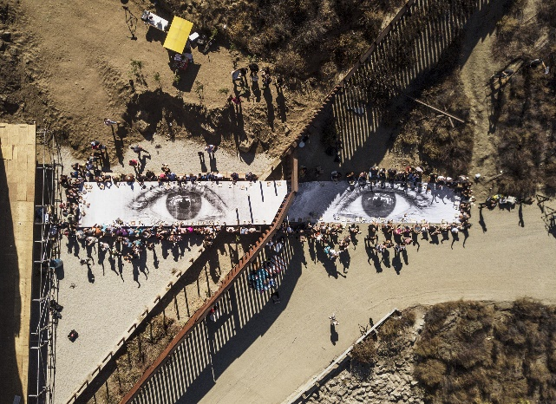
Photography by French artist JR

My idea is to show that in any given situation that seemingly reunites people, an idea or an utterance in a conversation can very easily divide them and create artificial, but clearly felt and communicated borders.

In my vision of the video that I want to produce, people are sitting at a table and enjoy a meal together; they are filmed from a bird ‘s-eye view. If possible, they should be quite diverse and in the beginning seem to be in harmony.

Beneath (Section Brief overview) find a proposal for the conversation. I would like to work on the conversation with the participants of the spot and incorporate their views and ideas.

How is your project challenging borders?

I want to show that borders and gaps between us can resolve from such tiny things as unthought utterances that categorize people. These utterances my help human kind to make sense of the world and to understand their surroundings. However, if these ideas are growing and develop from ideas to views and from views to so-called “knowledge” or stereotypes, they might eventually become laws and dictate our society.
This video should make all of us aware that we need to be careful with our language, as it is US who have the power to unite – in every sentence that we say.

Preparation (i.e. what will need to be done prior to the Forum, what will need to be during the Forum)

Prior to the forum we should collect already some phrases and probably on a google docs work already on the conversation that will be filmed. Also, the technical equipment should be found and the roles could divided.

During the Forum, we will have to finalize the conversation and maybe have several run-throughs. I would also like to find a spot where it could be filmed. Either it could be – as I imagine it in a rather dark room with light standing on the tables, or it could be in a spot that immediately allows for the audience to know where the movie was filmed. We might have to do several takes.

Brief overview of the performance

There should be as many people as possible sitting around the table and follow the conversation, which could take place as follows:

In the beginning you can only hear muttering and it is obvious that the people are having a good conversation.

Then you can suddenly follow the conversation better, as one person says very loud: “There is only two types of people: the ones that love coriander and the ones that hate it.” People then choose their side and communicate their preferences. As they state it; you do not need to hear one by another one, but it can be a lot of voices at the same time, they keep on eating (like coriander) or stand up (do not like coriander).
Then the conversation moves on: Person says “He is right, it is hardly possible to really categorize in this aspect. Very delicious this meal by the way. I will go for a second round.”

The people keep on eating. One person then says: ”You know, people also say that there is the ones that only study in the library and there is the ones that do never study in the library.” Again, the ones studying in the library stand up and the other stay seated.
In this way the conversation should go on and the phrases supposed to divide the people (in standing and sitting ones) will be uttered faster and faster. In between - if possible - the normal conversation should continue and all people sit down again and continue with their meal.

Further proposed statements:

- “Some can travel freely, some do not get a visa”
- “Some are always the ones that need to do the extra check up at the airport security, some do not”
- “Some are born in the European union and enjoy all rights, some moved here and have to fight for their rights”
- “Some have to fear every day that a war will out right next to them, some do not”
- “Some are women, some are men”

The conversation should then end by someone saying in a casual way: “And it is all these projections by society that divide us, focus on our differences and not similarities. It is exactly these created borders that allow for some to enjoy eternal freedom and others to be viewed as a threat to the European society’s security.”

Requirements for team members (e.g. specific skill, international group etc.)

- It would be great to have someone, who is very good with cameras and might even have their own. Otherwise, I studied communication and I have basic knowledge on filming and I own a photo camera that might also be usable for filming
- In order to play with the uniting and dividing factors, it would be really great to have a very diverse set of people. Hence a very international crowd would be nice, so we could also speak in diverse languages. But this is definitely not a must.
- You should be able to stand up and sit down again 😉

Some Information about myself:
Hello you all! I am Viktoria Arnold and I was born and raised in Vienna, Austria. I am very excited to be at Forum Alpbach for the first time and I am sure we are going to have a great time.
Currently I am doing my Master of Public Policy in Berlin and I work in the Labour Ministry – also here in Berlin. My work is focussed around the future of work and I am especially passionate about lifelong learning and how to design it in a way that allows to fight inequality.
In my free time I do a lot of sports and I love to watch movies as well as going to photo galleries. Hence, I also got the idea for this movie. Throughout my Bachelor of Communication, I had to do some movie projects, but I guess I am rather out of practice. So I need your help please!

